**SUBMISSION GUIDELINES FOR EST 2025 EXTENDED ABSTRACT**1 First A Author, and 2 Second B Author

1 Association name

2 Association name

Corresponding author email: est2025@xxx.edu.tw

**INTRODUCTION**

These instructions contain information about the abstract submission process and provide you with a template for formatting your abstract. All proceedings for the EST 2025 Congress must be submitted electronically via the official website, by January 15th, 2025. The abstract should be prepared using this template and must not exceed one page and use the two columns format. It will be used in the Congress Proceedings and will be online for all congress participants. It will also be used for the review process.

All abstracts must be submitted as a WORD file and can include only one figure or one table and must not be larger than 5 MB. Abstracts not meeting the required formatting will not be considered for review. Abstracts that are accepted for the conference will be included in the Congress Proceedings and available on the website.

**METHODS**

The abstract should be submitted using font Times New Roman or Times Roman 10 pt. The figure or table (if included) must be placed immediately after a paragraph. The title (in bold caps), authors, and author affiliations should be centered across the top of the page. Use numerical superscripts to distinguish authors who are from different institutions. An email address of the corresponding author should be included if desired. The presenting author should be in bold

The abstract is limited to one A4 size pages (210 x 297 mm), with two columns of text, justified. Top and bottom margins should be 20 mm, while left and right margins should be 15 mm.

The body of the manuscript should be divided into sections specifically titled as follows: Introduction, Methods, Results and Discussion, and Conclusions; all words in uppercase and bold. Text within each section should be right justified and left justified, without paragraph indentations. Use double line spacing between paragraphs.

All abstracts should be formatted using this document as a template. Please do not change formatting within the template document, as this may cause problems when it is included in the Proceedings. The congress organizers reserve the right to reject abstracts that do not adhere to the formatting guidelines in this document.  
  
**RESULTS AND DISCUSSION**

Figures and tables may be incorporated within the document and must be referenced in the text (Figure 1). Captions must be legible and placed below each Figure, and above each Table. Tables may extend across two columns when needed (Table 1). Use “Format → Columns” to control which parts of the text are in single column format.

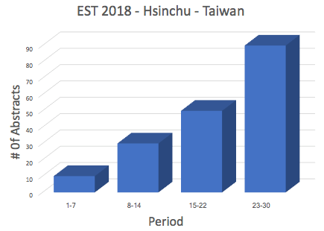

**Figure 1**: Number of expected abstracts for EST2018 per week in November 2017.

Reference citations within the text are to be made with numbers in square brackets [1,2]. References are to be formatted as illustrated below. Place the journal or book title in *Italics*, with volume numbers in **bold** [3]. Do not forget to remove citation formatting codes when using reference software such as Endnote© or Reference Manager©. Leaving the citations formatted for the applied reference software may create problems in formatting and lay-out.

**CONCLUSIONS**

The contributor must upload the article in Word format to the official conference website within the submission deadline to be considered a completed submission. If the uploaded data by the contributor is incomplete, the conference reserves the right to reject the submission. The submission will only enter the review process after the contributor has supplemented the information within the submission deadline. For the latest updates on this conference, please continue to follow the conference website (https://www.2025est.com/).

**ACKNOWLEDGEMENTS**Acknowledgments are optional and should specify research funding and resources including organization and reference numbers.

**REFERENCES**

1. Diller, T., Helmrich, G., Dunning, S., Cox, S., Buchanan, A., & Shappell, S. (2014). The human factors analysis classification system (HFACS) applied to health care. *American Journal of Medical Quality*, *29*(3), 181-190.
2. Tai, K. C., Lin, K. H., Hsieh, J. G., Chang, C. F., & Lee, Y. J. (2017, July). Effects of Taichi on static balance and leg muscle activities in community middle-aged and elderly. *Poster session presented at Proceedings of the congress of the International Society of Biomechanics*, Brisbane, Australia.